
QUALITY ALERT

Customer: Anlin Date: August 10, 2020
Die: 15394 Colour: Any
Type of Complaint: Customer REJECTED
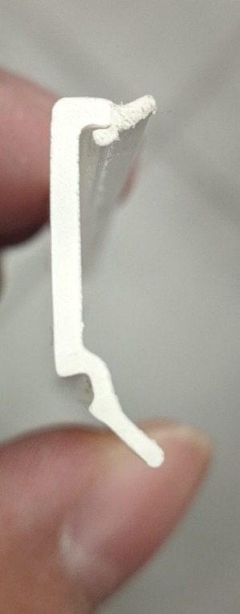
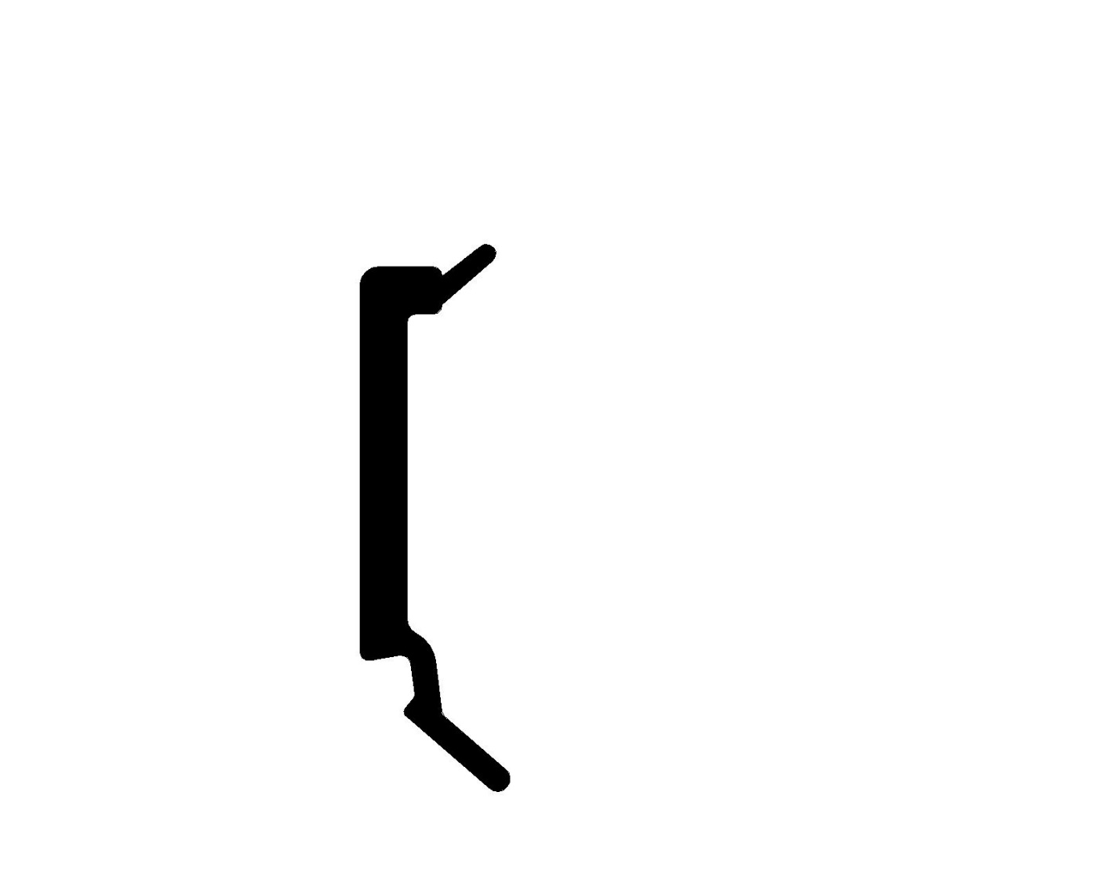
Q.A # Q.I.R # CUSTOMER NCR #

Description: Customer REJECTED shape and size of flex and flatness causing it to be tight in the punch.

Flex interfere with Punch when too big

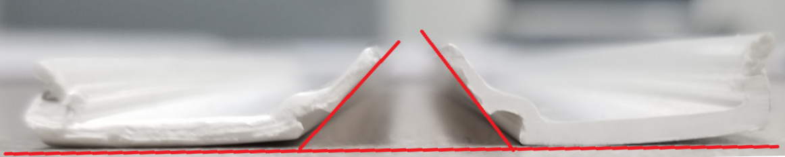
Flatness of the side so the leg interferes with the punch making it very tight.

BY SIGNING BELOW, YOU ACKNOWLEDGE THE PROBLEM ABOVE AND AGREE TO MONITOR THIS ISSUE IN FUTURE PRODUCTION RUNS.
DAY SHIFT |  | AFTERNOON SHIFT |  | NIGHT SHIFT
NAME | SIGNATURE | NAME | SIGNATURE | NAME | SIGNATURE

